|  |
| --- |
| Android SurfaceView |

1. [Static SurfaceView Creation in Android](http://sampleprogramz.com/android/surfaceview.php#Static SurfaceView Creation in Android)
2. [Dynamic SurfaceView Creation in Android](http://sampleprogramz.com/android/surfaceview.php#Dynamic SurfaceView Creation in Android)

Note                     [**Download ADT Plugin Here.**](http://developer.android.com/sdk/index.html)   
Here I am using,   
**OS :** Linux (Ubuntu 12.04)   
**Eclipse :** Juno (Version 4.2.0)   
**Android API Level :** 3 to 'n' as per need   
**Emulator API Level :** It will be displayed in output image

A. Static SurfaceView Creation in Android

Step 1 **:** Select File -> New -> Project -> Android Application Project (or) Android Project. Fill the forms and click "Finish" button. If you have any doubt regarding create a new project [Click Here](http://sampleprogramz.com/android/new.php).

Step 2 **:** Open res -> layout -> **activity_main.xml (or) main.xml** and add following code :

<LinearLayout xmlns:android="http://schemas.android.com/apk/res/android"

xmlns:tools="http://schemas.android.com/tools"

android:orientation="vertical"

android:layout_width="match_parent"

android:layout_height="match_parent" >

<RelativeLayout

android:layout_width="match_parent"

android:layout_height="wrap_content">

<TextView

android:id="@+id/textView1"

android:textColor="#8B008B"

android:textSize="19dp"

android:layout_centerHorizontal="true"

android:layout_marginTop="40dp"

android:layout_width="wrap_content"

android:layout_height="wrap_content"

android:text="Static SurfaceView" />

</RelativeLayout>

<RelativeLayout

android:layout_width="match_parent"

android:layout_height="wrap_content">

<SurfaceView

android:id="@+id/surfaceView1"

android:background="#1E90FF"

android:layout_centerHorizontal="true"

android:layout_marginTop="40dp"

android:layout_width="wrap_content"

android:layout_height="wrap_content" />

<TextView

android:id="@+id/textView2"

android:textColor="#FFF"

android:textSize="18dp"

android:layout_width="wrap_content"

android:layout_height="wrap_content"

android:layout_alignTop="@+id/surfaceView1"

android:layout_marginTop="25dp"

android:layout_centerHorizontal="true"

android:text="TextView" />

<Button

android:id="@+id/button1"

android:layout_width="wrap_content"

android:layout_height="wrap_content"

android:layout_centerHorizontal="true"

android:layout_centerVertical="true"

android:text="Button" />

</RelativeLayout>

</LinearLayout>

Step 3 **:** Open src -> package -> **MainActivity.java** and add following code :

package balaji.surfaceview_static;

import android.os.Bundle;

import android.app.Activity;

import android.view.Menu;

import android.view.SurfaceView;

import android.view.View;

import android.widget.Button;

import android.widget.Toast;

public class MainActivity extends Activity {

SurfaceView sv;

Button b;

@Override

public void onCreate(Bundle savedInstanceState) {

super.onCreate(savedInstanceState);

setContentView(R.layout.activity_main);

sv = (SurfaceView) findViewById(R.id.surfaceView1);

b = (Button) findViewById(R.id.button1);

b.setOnClickListener(new View.OnClickListener() {

@Override

public void onClick(View v) {

// TODO Auto-generated method stub

Toast.makeText(getBaseContext(), "Cooooool",

Toast.LENGTH_SHORT).show();

}

});

}

@Override

public boolean onCreateOptionsMenu(Menu menu) {

getMenuInflater().inflate(R.menu.activity_main, menu);

return true;

}

}

Step 4 **:** Open **AndroidManifest.xml** and add following code :

<manifest xmlns:android="http://schemas.android.com/apk/res/android"

package="balaji.surfaceview_static"

android:versionCode="1"

android:versionName="1.0" >

<uses-sdk

android:minSdkVersion="3"

android:targetSdkVersion="15" />

<application

android:icon="@drawable/ic_launcher"

android:label="@string/app_name"

android:theme="@style/AppTheme" >

<activity

android:name=".MainActivity"

android:label="@string/title_activity_main" >

<intent-filter>

<action android:name="android.intent.action.MAIN" />

<category android:name="android.intent.category.LAUNCHER" />

</intent-filter>

</activity>

</application>

</manifest>

Step 5 **:** Open res ->values ->**strings.xml** and add following code :

<resources>

<string name="app_name">SurfaceView_Static</string>

<string name="hello_world">Hello world!</string>

<string name="menu_settings">Settings</string>

<string name="title_activity_main">MainActivity</string>

</resources>

Step 6 **:** Our output will be like this :

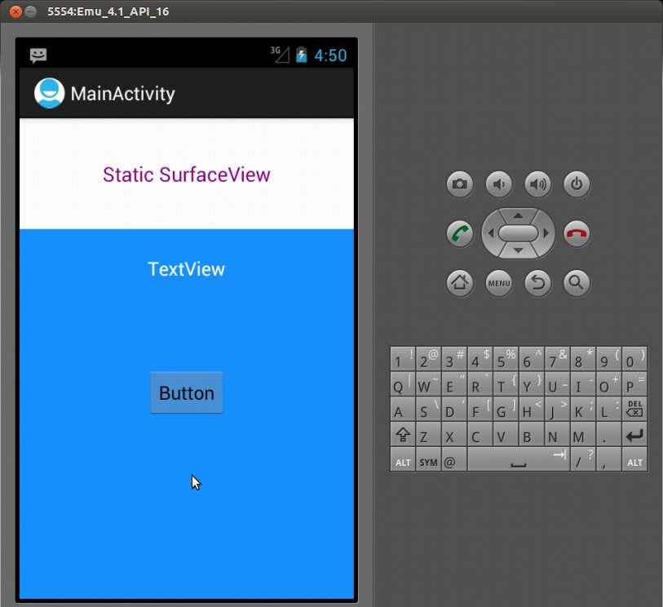

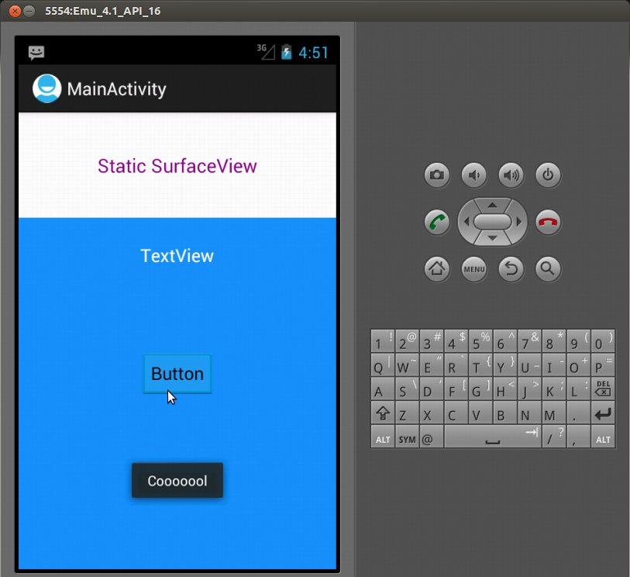

B. Dynamic SurfaceView Creation in Android

Step 1 **:** Select File -> New -> Project -> Android Application Project (or) Android Project. Fill the forms and click "Finish" button. If you have any doubt regarding create a new project [Click Here](http://sampleprogramz.com/android/new.php).

Step 2 **:** Open res -> layout -> **activity_main.xml (or) main.xml** and add following code :

<LinearLayout xmlns:android="http://schemas.android.com/apk/res/android"

xmlns:tools="http://schemas.android.com/tools"

android:orientation="vertical"

android:layout_width="match_parent"

android:layout_height="match_parent" >

<RelativeLayout

android:layout_width="match_parent"

android:layout_height="wrap_content">

<TextView

android:id="@+id/textView1"

android:textColor="#8B008B"

android:textSize="19dp"

android:layout_centerHorizontal="true"

android:layout_marginTop="40dp"

android:layout_width="wrap_content"

android:layout_height="wrap_content"

android:text="Dynamic SurfaceView" />

</RelativeLayout>

<RelativeLayout

android:id="@+id/rl"

android:layout_width="match_parent"

android:layout_height="wrap_content" />

</LinearLayout>

Step 3 **:** Open src -> package -> **MainActivity.java** and add following code :

package balaji.surfaceview_dynamic;

import android.os.Bundle;

import android.app.Activity;

import android.graphics.Color;

import android.view.Menu;

import android.view.SurfaceView;

import android.view.View;

import android.widget.Button;

import android.widget.RelativeLayout;

import android.widget.TextView;

import android.widget.Toast;

import android.widget.RelativeLayout.LayoutParams;

public class MainActivity extends Activity {

RelativeLayout rl;

SurfaceView sv;

Button b;

TextView tv;

@Override

public void onCreate(Bundle savedInstanceState) {

super.onCreate(savedInstanceState);

setContentView(R.layout.activity_main);

rl = (RelativeLayout) findViewById(R.id.rl);

sv = new SurfaceView(MainActivity.this);

RelativeLayout.LayoutParams params = new RelativeLayout.LayoutParams

((int) LayoutParams.WRAP_CONTENT, (int) LayoutParams.WRAP_CONTENT);

params.addRule(RelativeLayout.CENTER_HORIZONTAL);

params.topMargin = 40;

sv.setLayoutParams(params);

sv.setBackgroundColor(Color.LTGRAY);

tv = new TextView(MainActivity.this);

b = new Button(MainActivity.this);

tv.setText("TextView");

b.setText("Button");

RelativeLayout.LayoutParams params1 = new RelativeLayout.LayoutParams

((int) LayoutParams.WRAP_CONTENT, (int) LayoutParams.WRAP_CONTENT);

RelativeLayout.LayoutParams params2 = new RelativeLayout.LayoutParams

((int) LayoutParams.WRAP_CONTENT, (int) LayoutParams.WRAP_CONTENT);

params1.addRule(RelativeLayout.CENTER_HORIZONTAL);

params2.addRule(RelativeLayout.CENTER_IN_PARENT);

params1.topMargin = 75;

tv.setLayoutParams(params1);

b.setLayoutParams(params2);

rl.addView(sv);

rl.addView(tv);

rl.addView(b);

b.setOnClickListener(new View.OnClickListener() {

@Override

public void onClick(View v) {

// TODO Auto-generated method stub

Toast.makeText(getBaseContext(), "Cool Buddy",

Toast.LENGTH_SHORT).show();

}

});

}

@Override

public boolean onCreateOptionsMenu(Menu menu) {

getMenuInflater().inflate(R.menu.activity_main, menu);

return true;

}

}

Step 4 **:** Open **AndroidManifest.xml** and add following code :

<manifest xmlns:android="http://schemas.android.com/apk/res/android"

package="balaji.surfaceview_dynamic"

android:versionCode="1"

android:versionName="1.0" >

<uses-sdk

android:minSdkVersion="3"

android:targetSdkVersion="15" />

<application

android:icon="@drawable/ic_launcher"

android:label="@string/app_name"

android:theme="@style/AppTheme" >

<activity

android:name=".MainActivity"

android:label="@string/title_activity_main" >

<intent-filter>

<action android:name="android.intent.action.MAIN" />

<category android:name="android.intent.category.LAUNCHER" />

</intent-filter>

</activity>

</application>

</manifest>

Step 5 **:** Open res ->values ->**strings.xml** and add following code :

<resources>

<string name="app_name">SurfaceView_Dynamic</string>

<string name="hello_world">Hello world!</string>

<string name="menu_settings">Settings</string>

<string name="title_activity_main">MainActivity</string>

</resources>

Step 6 **:** Our output will be like this :

